Floating Garden’s Launch Event – Thursday 5th June 08 (Sale – Dunham)
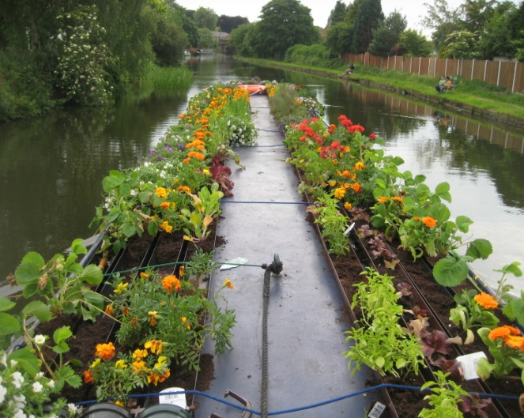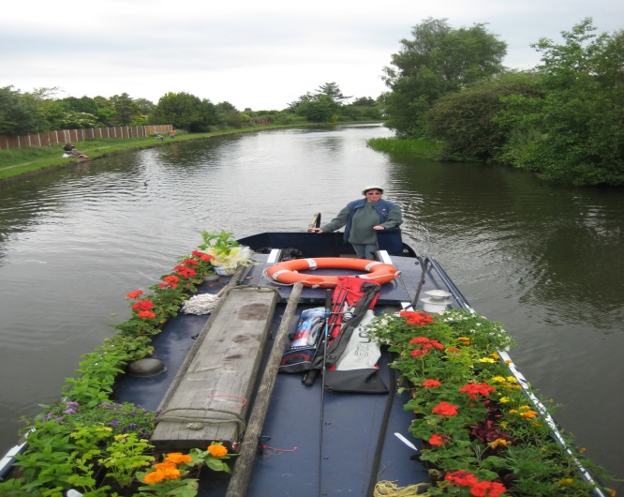
The launch event at the Kings Ransom, Sale I think was a huge success. We had a large group of young people from different schools across Trafford, getting involved in different workshops. Workshops included; circus skills run by Mark Edwards (Trafford Youth Service) which involved juggling, plate spinning, Diablo’s and more, mini beast hunt (insects) ran by Chantal (United Utilities) which involved looking at a number of insects under a microscope and on a big TV screen. I thought this was amazing. We also gave out loads of free gifts such as wind up phone chargers, information on how to save water and electricity packs. John Fletcher – IWA (Inland Waterways Association) and Will Owen (Head of Youth Service) gave a short speech to launch the event. Then we set off for our first destination, Dunham on the Prince William a 70ft community narrow boat run by The Open Lock Project - part of Trafford’s Children and Young People’s service.
James Coates (Volunteer, Open Lock Project)
Travelling time:
Cruising time - hours | Miles | Locks
2 | 5 | 0

Floating Garden’s Day 2 – Friday 6th June 08 (Dunham – Oughtrington)
We travelled from Dunham to “The Old No 3”, where we filled up with water. We stopped off at Hesfords Boat Yard, where we got paint and rollers. We then went to Spud Wood just outside of Oughtrington. On arrival we moored up, had some tea and then decided to paint the port (left) side of the boat with a fresh paint job.
James Coates (Volunteer, Open Lock Project)
Travelling time:
Cruising time - hours | Miles | Locks
1.5 | 4 | 0

Floating Garden’s Day 3 – Saturday 7th June 08
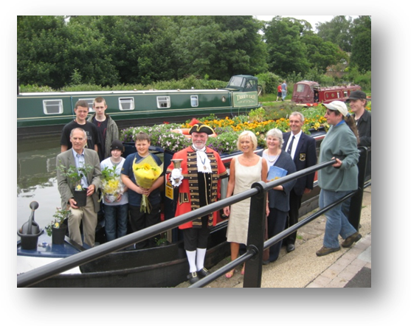(Oughtrington – Lymm, Lymm to Stockton Heath)
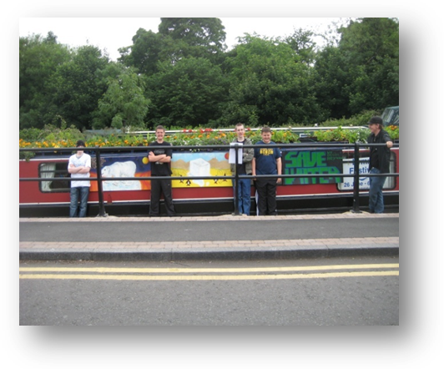Today we started at Oughtrington were we met the boat. Then we started to sail to lymm. When we got there we met the town crier called Peter Powell, Ian Marks who is the leader of Warrington borough council, Honor Giles who is Lymm festival director and Dave Ross who is the commodore of lymm cruising club.

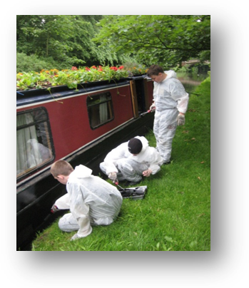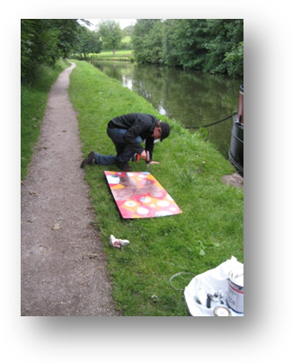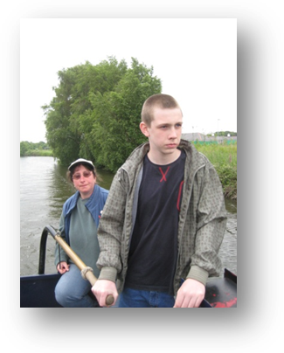

We exchanged a king’s ransom rose and we received an Inula hookeri plant and a bouquet of flowers. I got my picture taken by the Warrington guardian, I was watering the flowers on the roof.
(Jamie -13 - Partington Youth Centre)
When we left Lymm and sailed down to Thorn Marine and re-filled the boat with diesel and water and emptied the toilets. We then sailed down to Hough’s Bridge and we had a barbecue. We also painted the side skirts of the boat. After that we had a little free time and we went fishing. It was quite fun actually.
(Jordan - 12 - Partington Youth Centre)

Travelling time: Oughtrington to Lymm
Cruising time - hours | Miles | Locks
0.25 | 1 | 0

Travelling time: Lymm – Stockton Heath
Cruising time - hours | Miles | Locks
1.75 | 6 | 0

